Objective

To build a dashboard that will present monthly sales performance by product segment and product category to help client identifying the segments and categories that have met or exceeded their sales targets, as well as those that have not met their sales targets.

Analysis Tasks

1. Use the Saved Sample – Superstore dataset.
2. Create a bullet chart with Category and Segment dimensions and Sales measures.
3. Blend the data with the Saved Sample - Sales Target data set to bring in the Sales Target measure.
4. Color code the chart to identify Categories and Segments that are above or below target.
5. Add the year of sales to the view to identify trends and outliers.
6. Add a filter so that the user can select one, more than one, or all years.
7. Create a dashboard with this view.

Sheet View

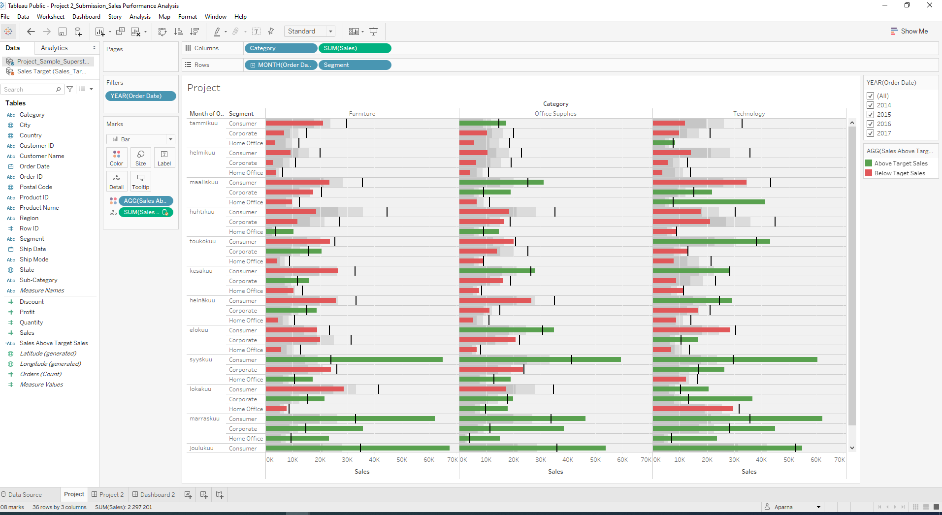

Dashboard View

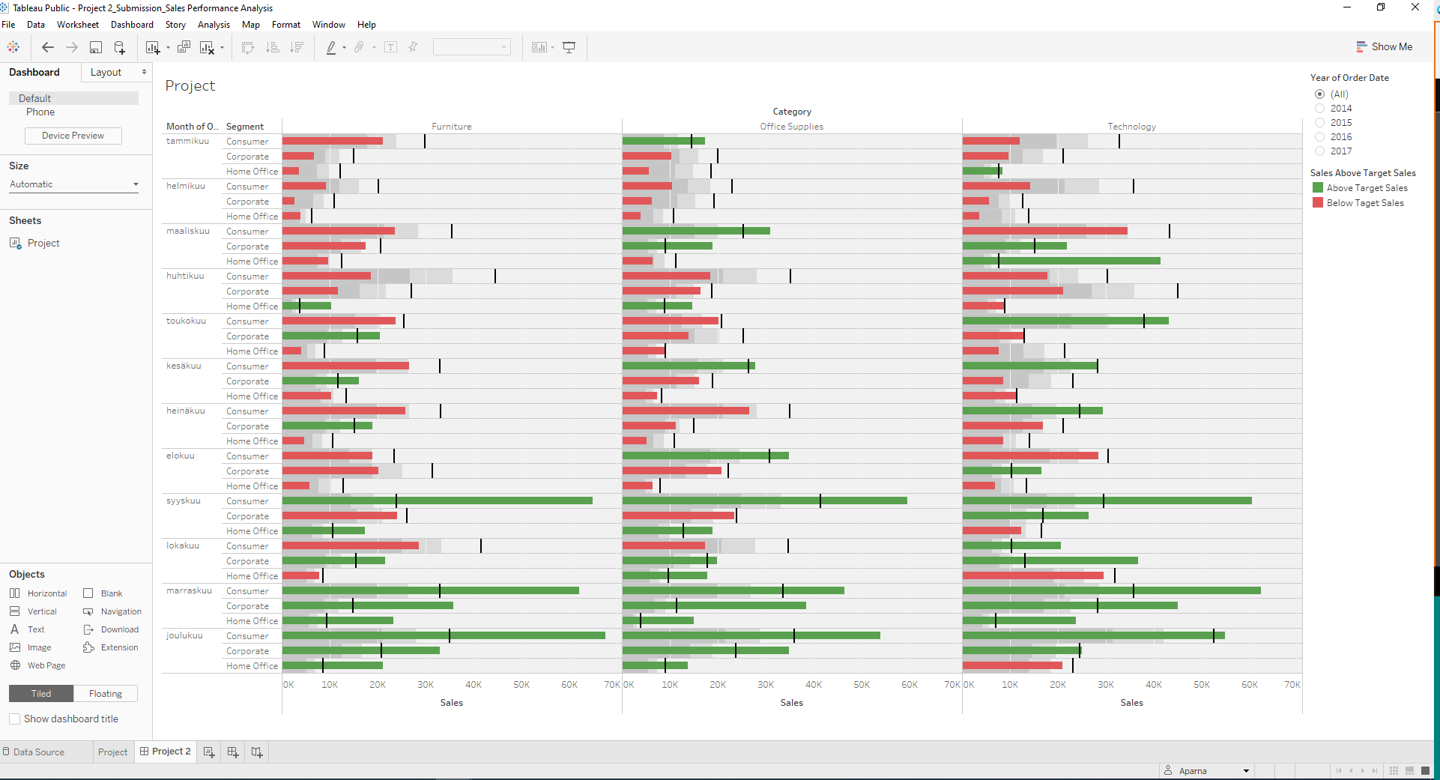

Saved in Tableau Public Server

https://public.tableau.com/profile/aparna6616#!/vizhome/Project2_Submission_SalesPerformanceAnalysis/Project2